050812_002C Assembly Drawing - – PCB Dimensions: 0.646” x 0.51”

11/15/16

TOP

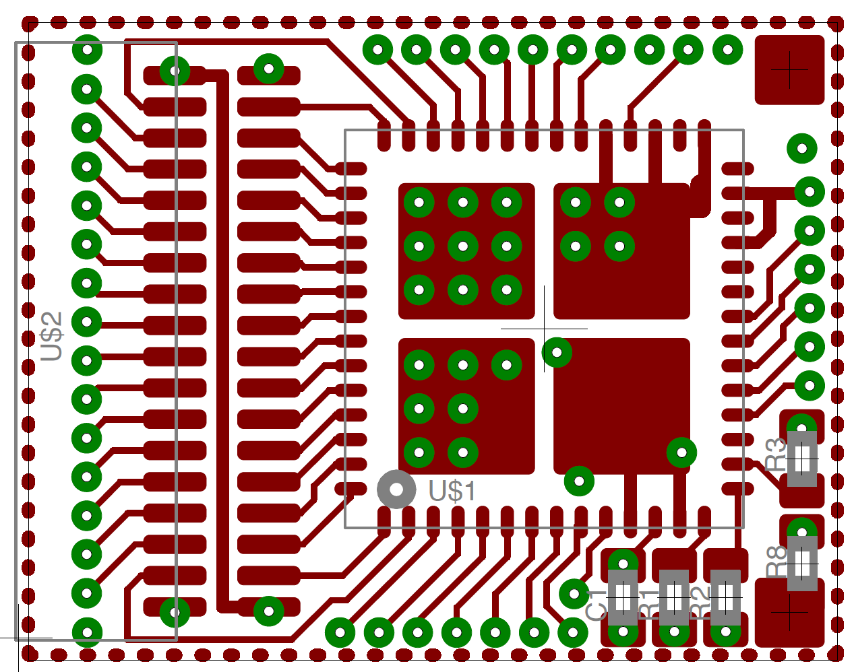

050812_002C Assembly Drawing

Bottom

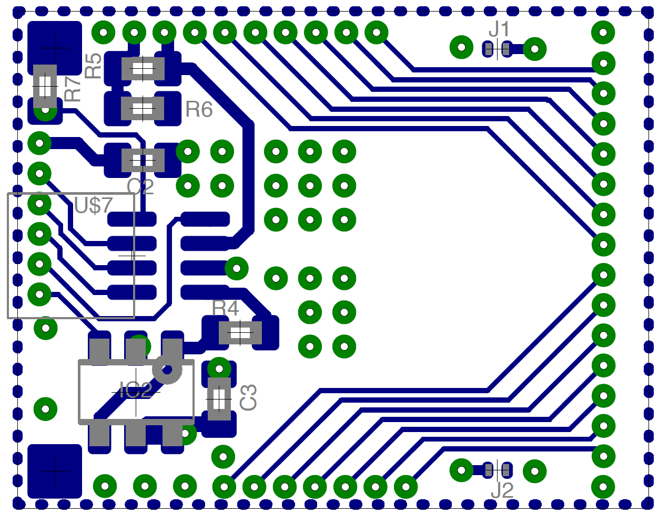

TOP Side – correct orientation of connectors – Note: Illustration only - SMT components in picture or not the same as assembly job

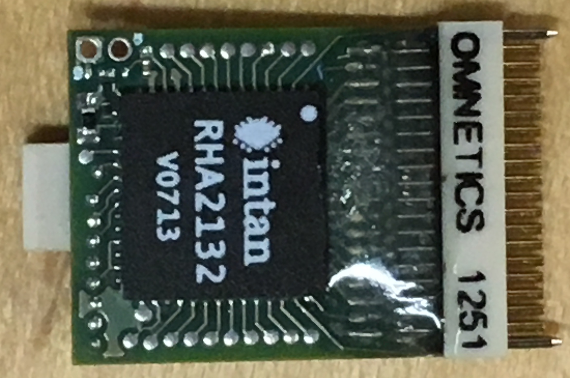

BOTTOM Side – correct orientation of connectors - Note: Illustration only - SMT components in picture or not the same as assembly job

